EXPERIMENT 18
Set up a CI/CD Pipeline to Automate the Building, Testing,
and Deployment of a Containerized Application using Jenkins

AIM
To set up a CI/CD pipeline using Jenkins to automate the building, testing, containerization and deployment of a Dockerized application.

THEORY
Continuous Integration and Continuous Deployment (CI/CD) automate the software development lifecycle. Jenkins is an automation server that can obtain source code from GitHub, execute automated tests, build Docker images and deploy applications. A Jenkinsfile defines the pipeline as code and organizes the workflow into stages. In this experiment, the pipeline performs source checkout, Docker image creation, testing, Docker Hub publishing and deployment.

PROCEDURE
- Install and start Jenkins on the local machine or server.
- Create the application source code and Dockerfile.
- Create a Jenkinsfile containing Checkout, Build Docker Image, Run Tests, Push to Docker Hub and Deploy stages.
- Create a Jenkins Pipeline job and connect it to the GitHub repository.
- Configure Docker Hub/GitHub credentials securely in Jenkins.
- Configure a GitHub webhook or SCM trigger to start the pipeline when code is pushed.
- Run the Jenkins pipeline and monitor the Console Output.
- Verify that the application tests execute successfully.
- Verify that the Docker image is built and pushed to Docker Hub.
- Deploy the containerized application and access it through the browser.

IMPLEMENTATION
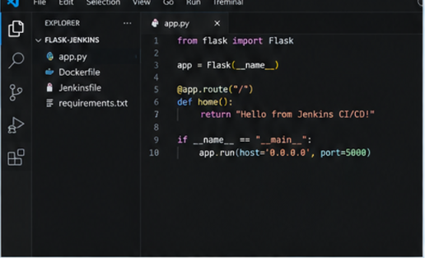
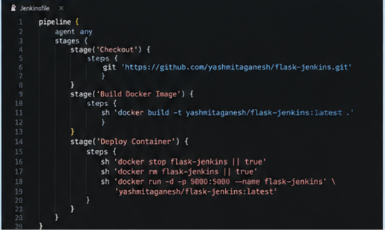
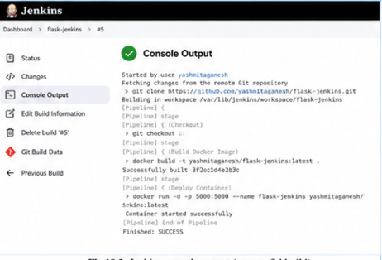
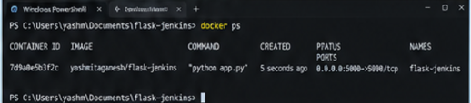
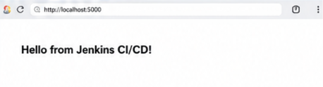
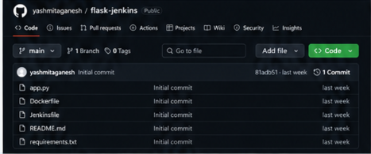

IMPLEMENTATION DETAILS
Parameter | Value
Repository | yashmitaganesh/To-Do-App-Docker-Practice
Pipeline | todo-app-pipeline
CI/CD Tool | Jenkins
Container Platform | Docker
Container Registry | Docker Hub
Docker Image | yashmitaganesh/todo-app:latest
Application | Flask Todo Application
Application Port | 5000
Deployment Access | http://localhost:3001
Pipeline Status | SUCCESS

JENKINSFILE PIPELINE STAGES
- Checkout — retrieves the project from GitHub.
- Build Docker Image — creates the application image.
- Run Tests — executes the application's automated tests.
- Push to Docker Hub — publishes the image as yashmitaganesh/todo-app:latest.
- Deploy — runs the containerized application for verification.

OUTPUT
The Jenkins pipeline executed successfully. The source code was checked out, the Docker image was built, tests were executed successfully, the image was pushed to Docker Hub, and the containerized Todo application was deployed and accessed through the browser.

RESULT
Thus, a CI/CD pipeline using Jenkins was successfully implemented for a Dockerized application. The pipeline automated source checkout, testing, Docker image creation, image publishing and deployment.

COMMANDS / PIPELINE OPERATIONS
docker build -t yashmitaganesh/todo-app:latest .
docker push yashmitaganesh/todo-app:latest
docker run -d -p 3001:5000 --name todo-app yashmitaganesh/todo-app:latest

VERIFICATION
Jenkins Console Output shows the pipeline completed successfully. The Docker Hub repository contains the published image, and the Todo application is available through the configured browser port.

